1. Create Standard Invoice:
   1. Invoice workbench:
      1. Header data
         1. Invoice Type (Standard)
         2. Invoice Num
         3. Trading Partner
         4. Supplier Site
         5. Invoice Date
         6. Invoice Amount

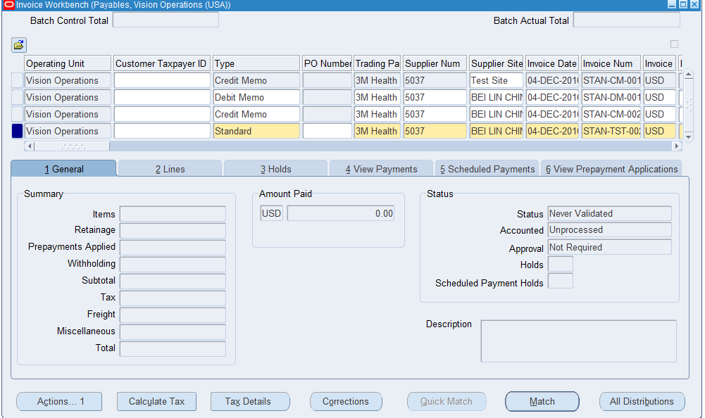

Line Data & Distribution

* Enter Line Amount
* Distributions -> Enter Distribution amount -> Enter Distribution Account

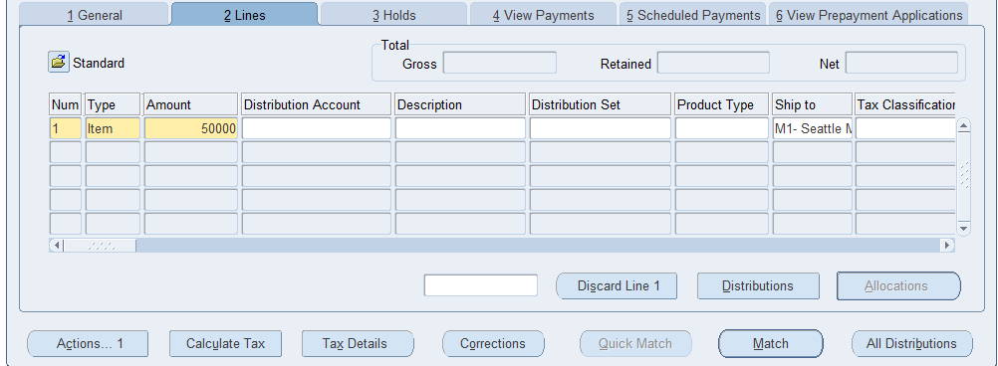

Actions>Validate

* Validate the Invoice for errors and corrections.

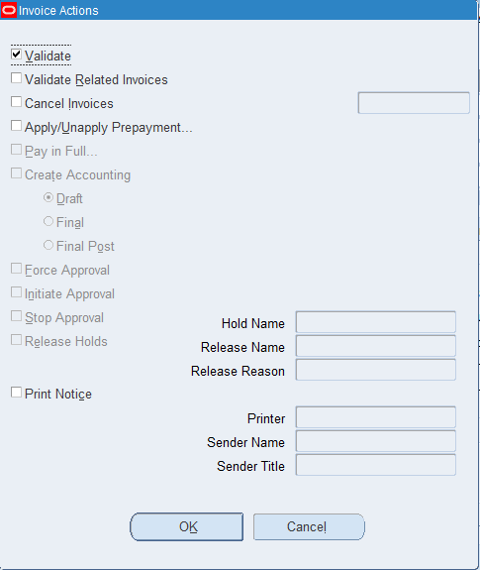

Actions>Create Accounting> Final Post

* Post the Invoice into the accounting process

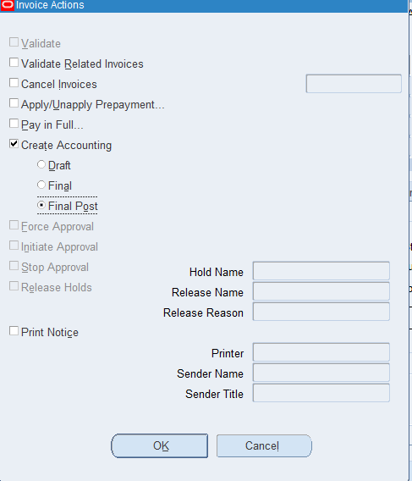

1. Create Payment

Actions>pay-in-full>Ok

* Payment Workbench will appear, and we will need to input the data

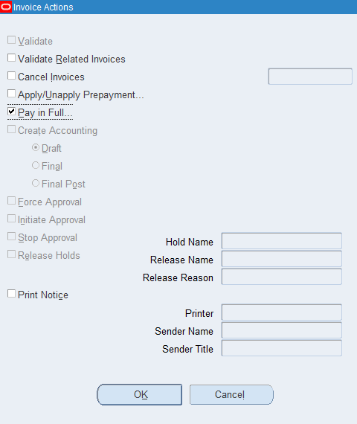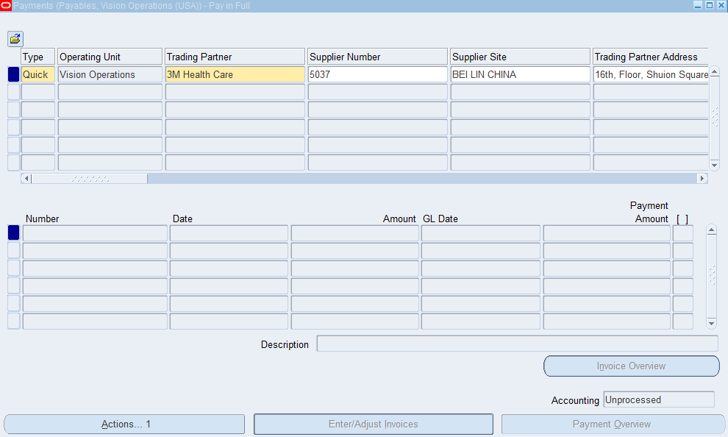

* Payment date: 04-DEC-2016
* Payment Process Profile: Check USD
* Save

Actions>Create Accounting > Final Post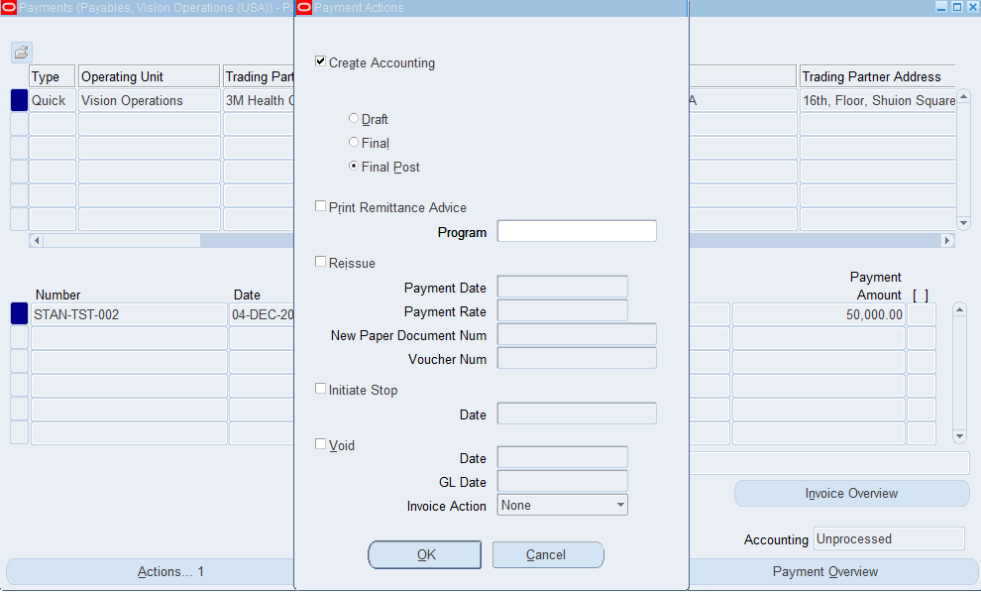

Actions>Print Remittance Advice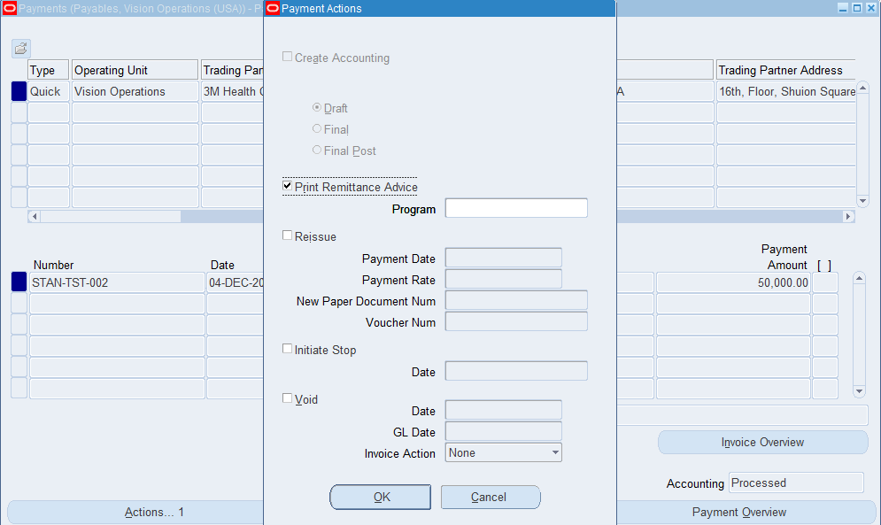

Requery Invoice

